 Install the Apache web server in EC2 instance and create a golden image from it

Click on service,then search EC2 , launch EC2 instance.in that firststep choose amazon IAM

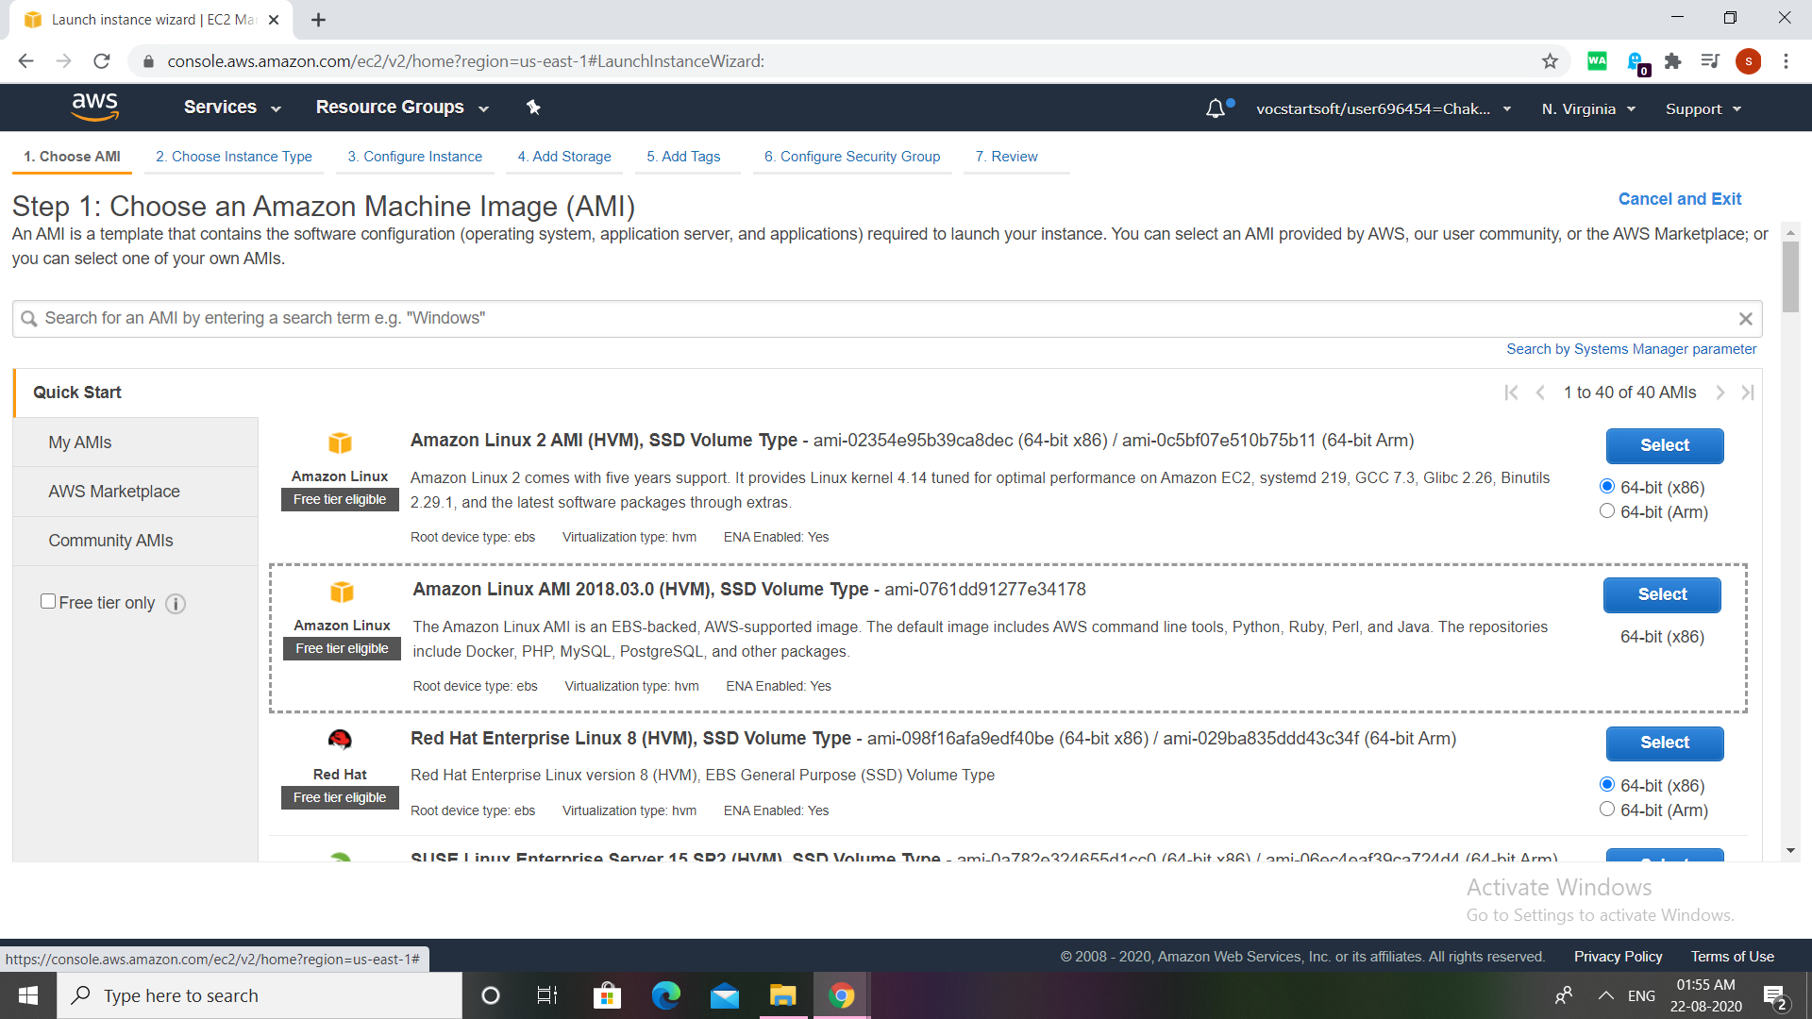

Choose free tire , t2 micro

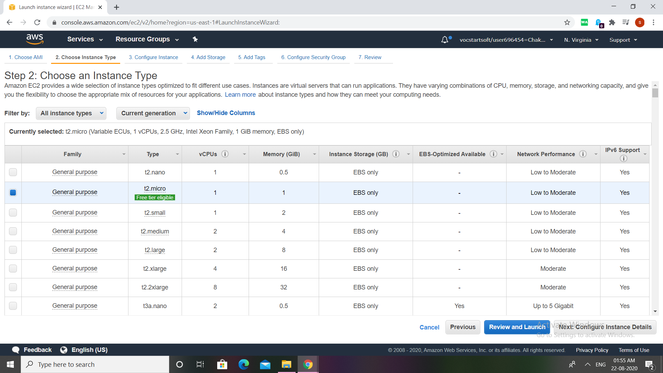

Config instance deatails as defaultAdd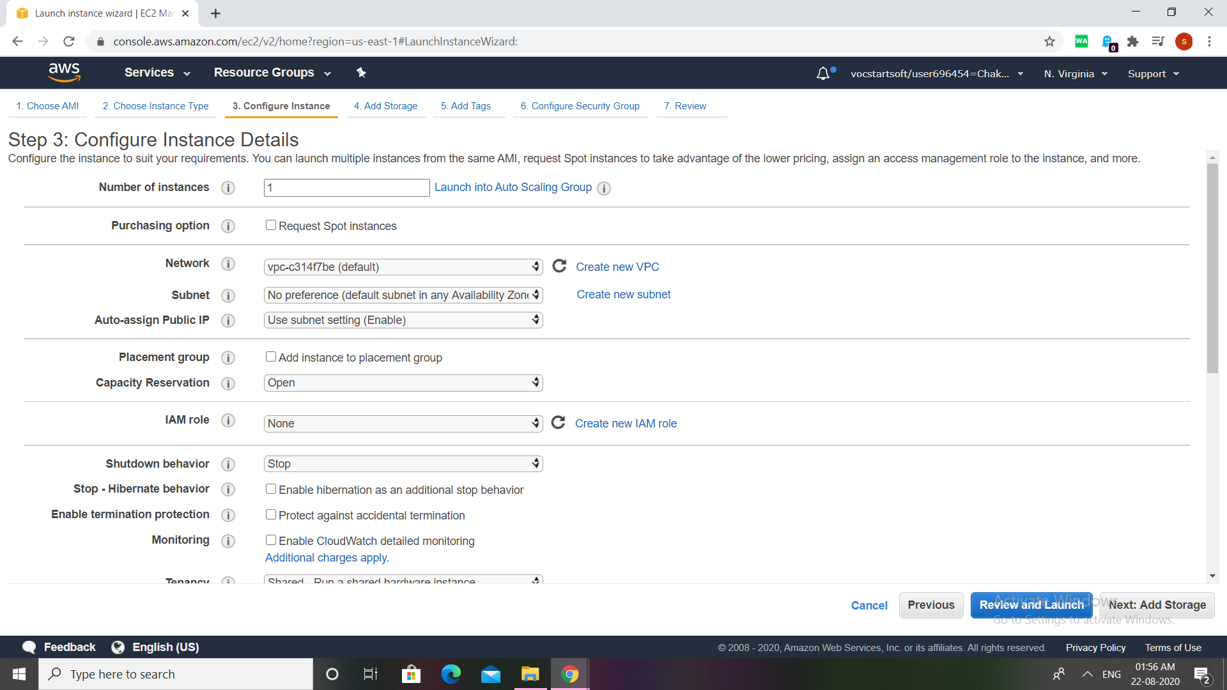

Add storage

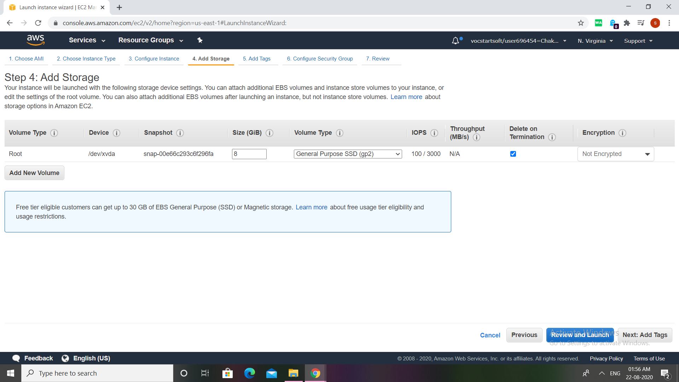

Add tags if we want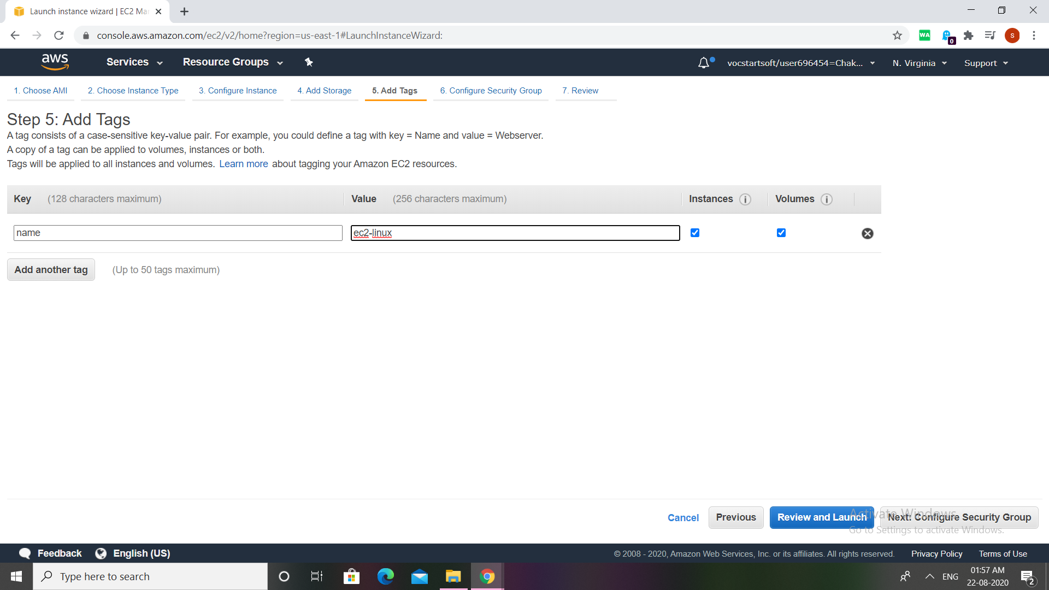

Create or select security groups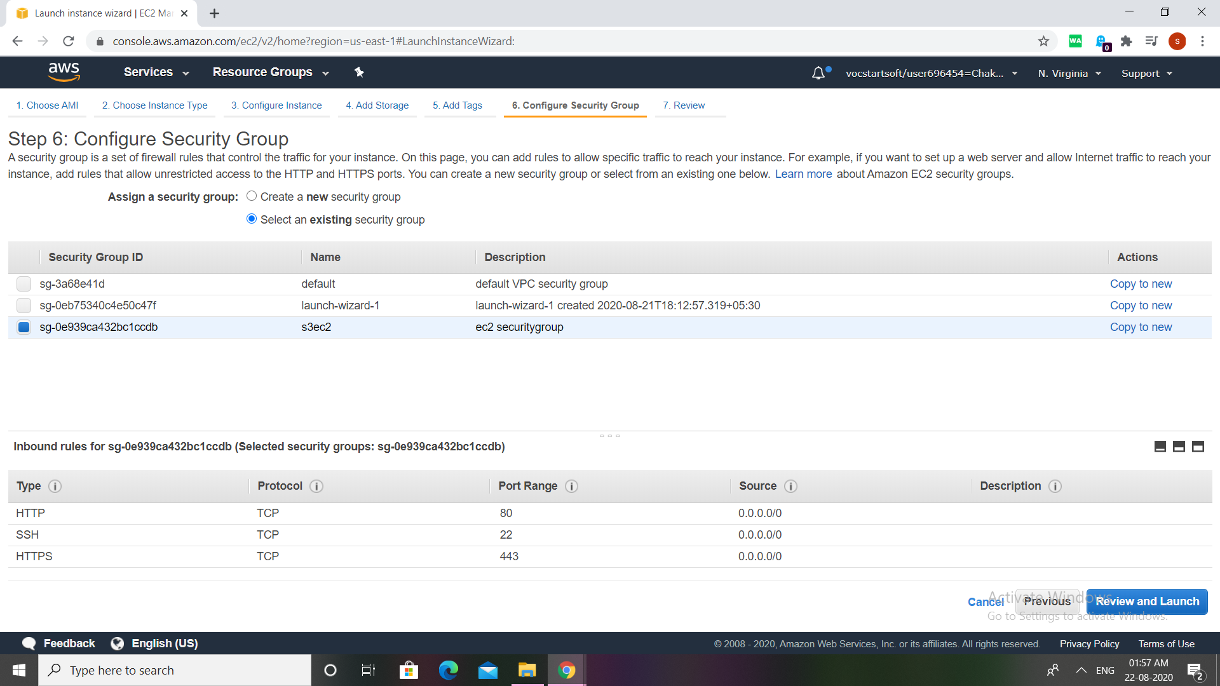Review all what are all we created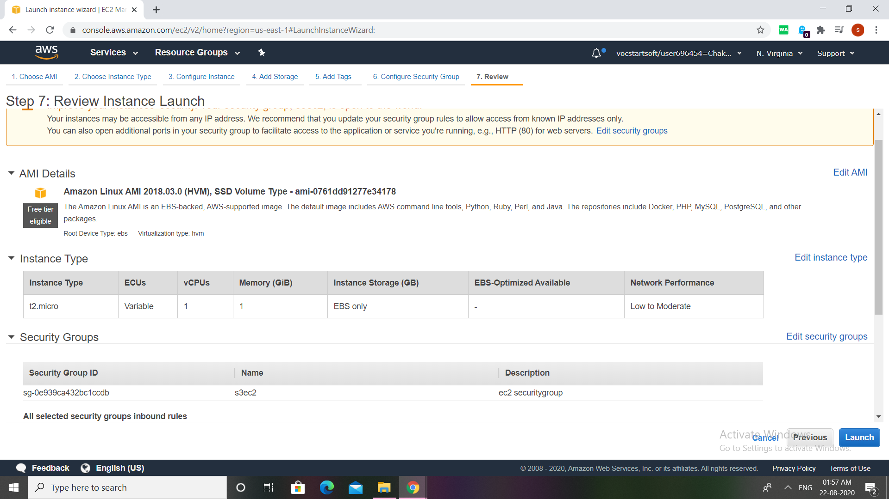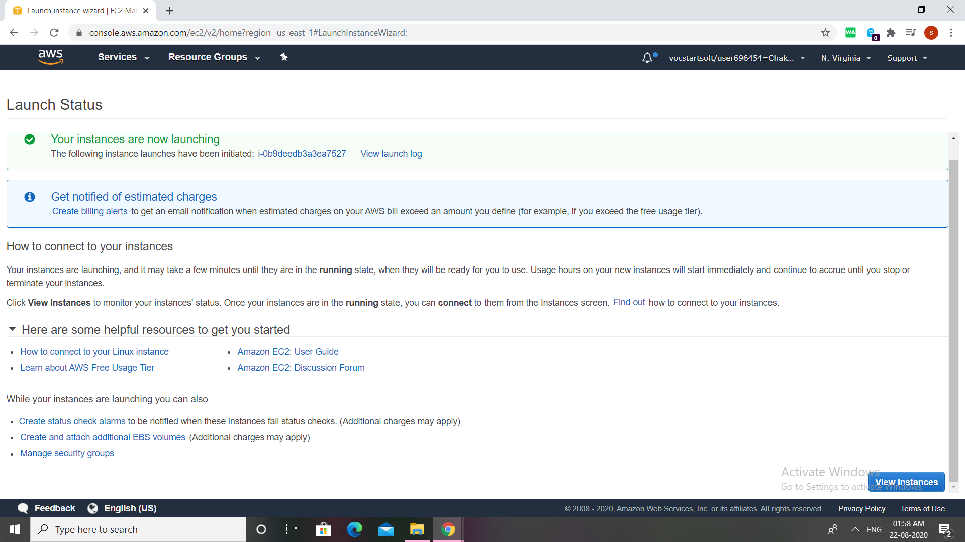

Launch the instance and copy the ip address paste it on browser before that write 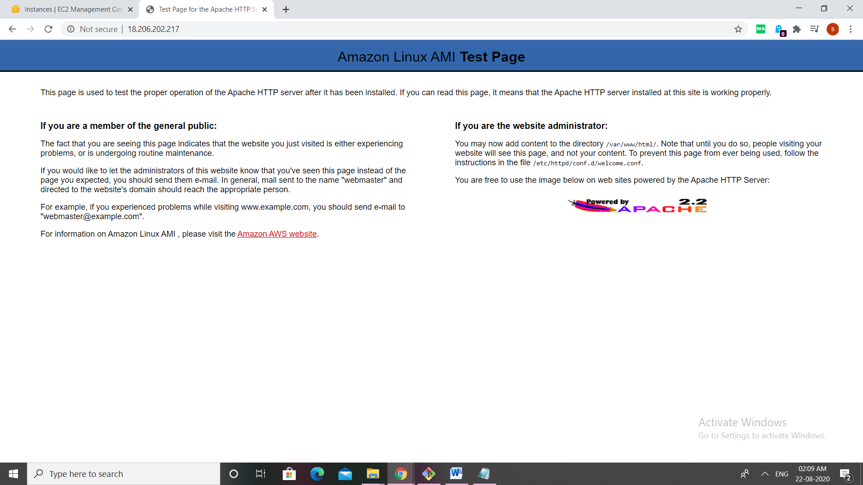some commands then refresh it u will get the output

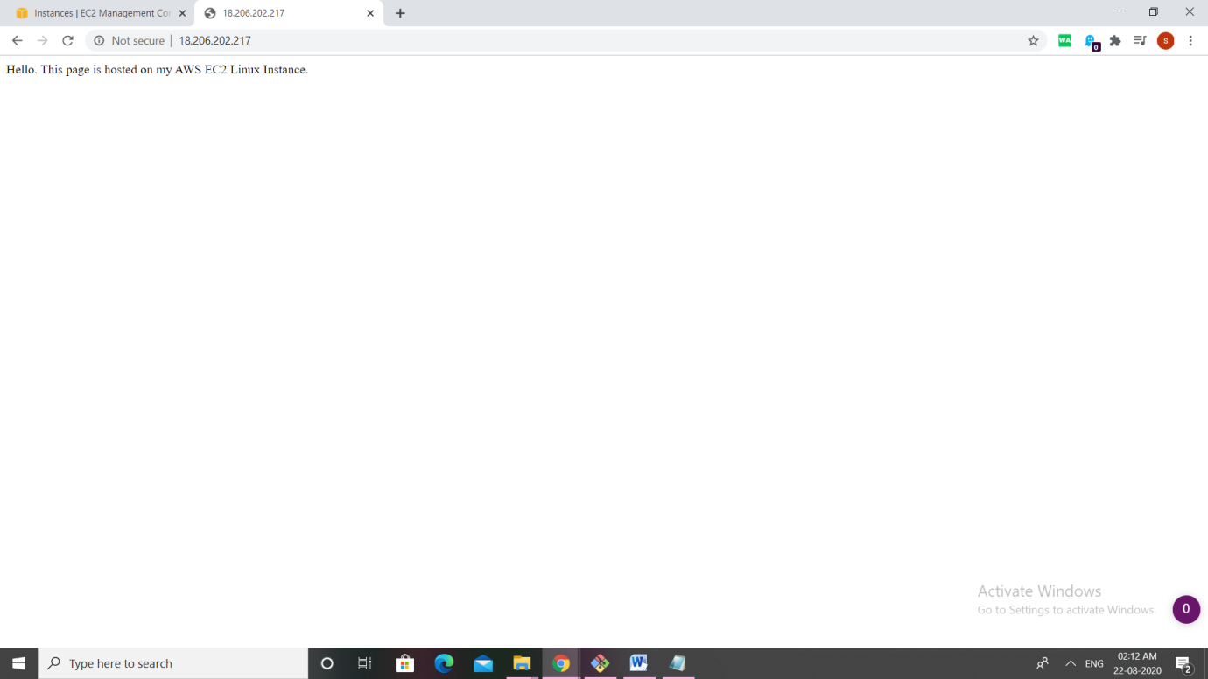

Now lets go to instance click on running instance next click on Action images ,next click on create images,there we can create own instance

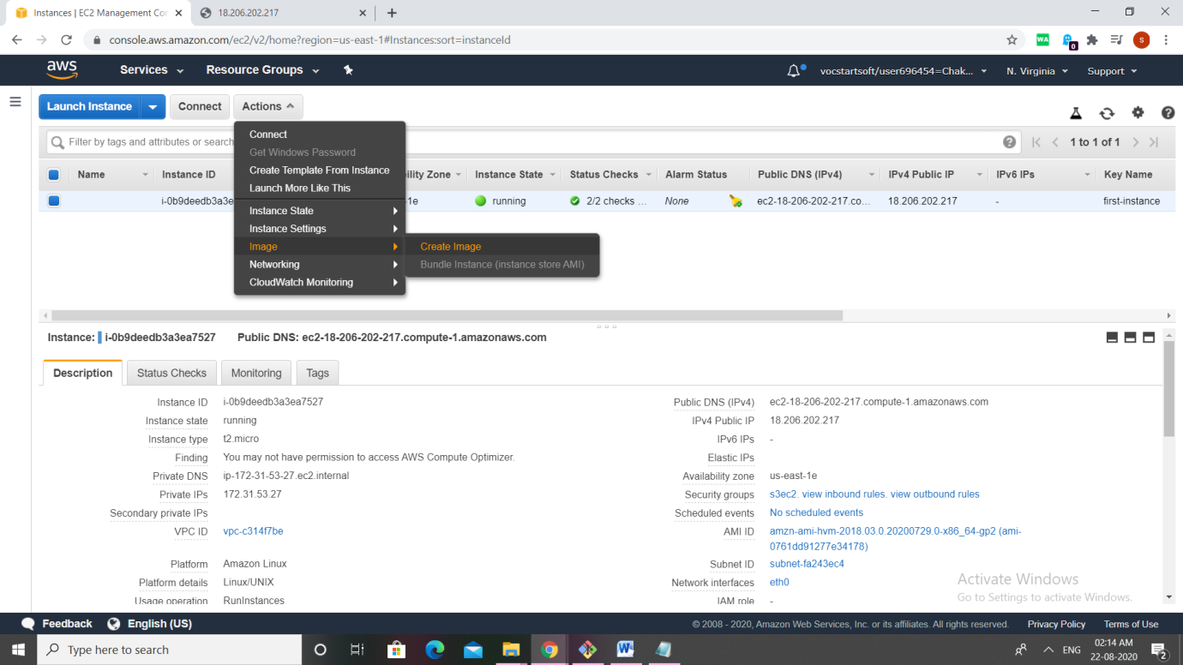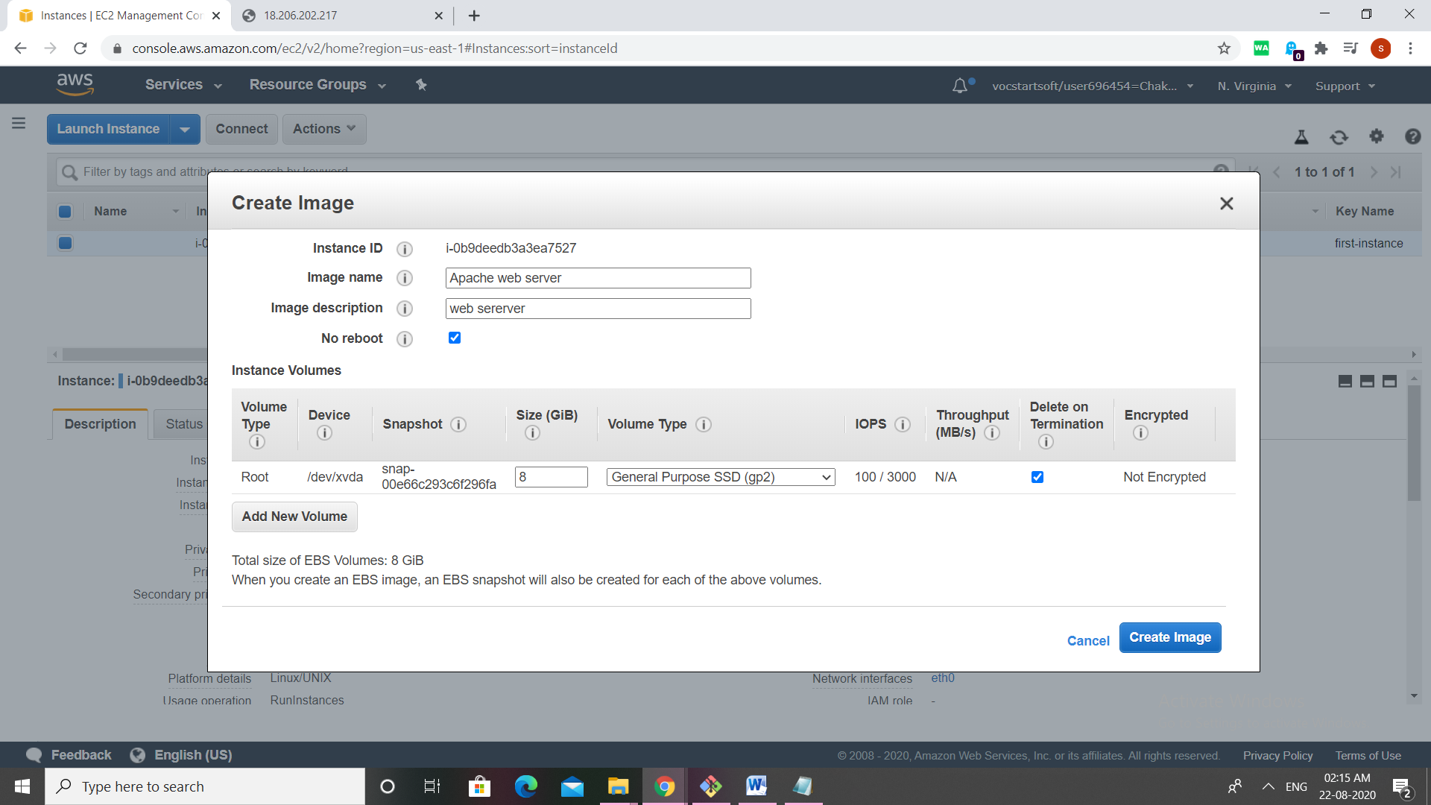

This image is created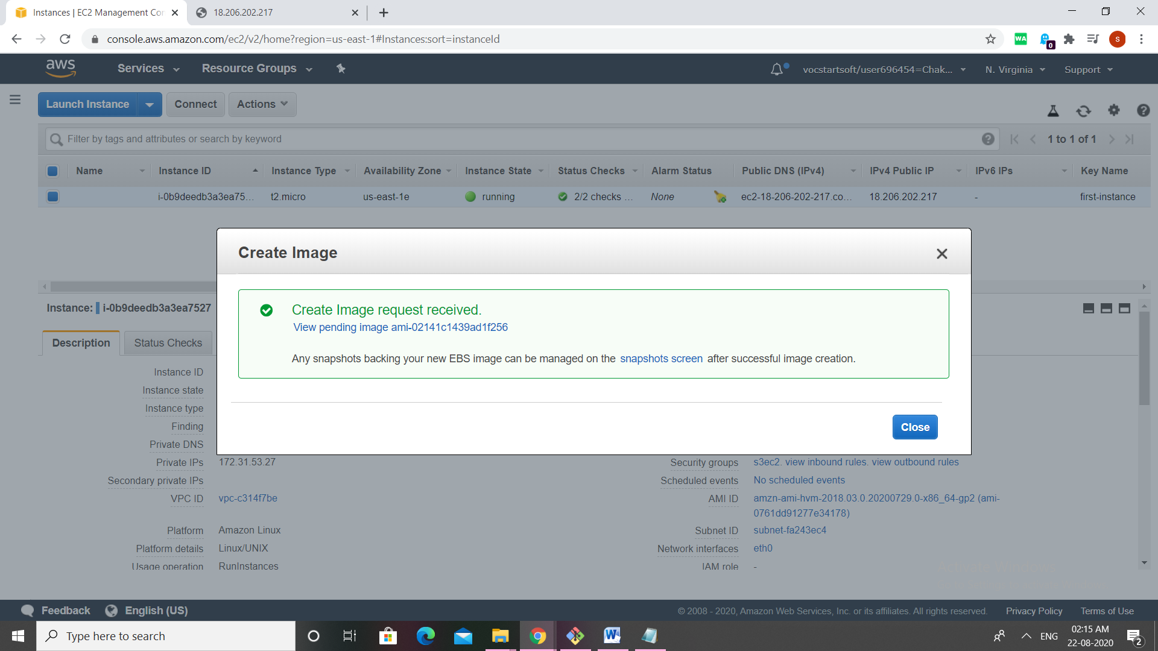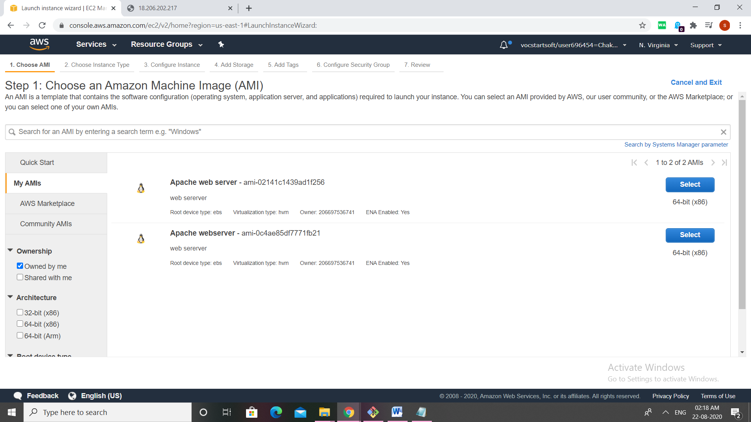

Now create an instance again and click on IAM from my IAM ,next all process same run it copy the public ip then pafste the public ip on browser then we find the same output.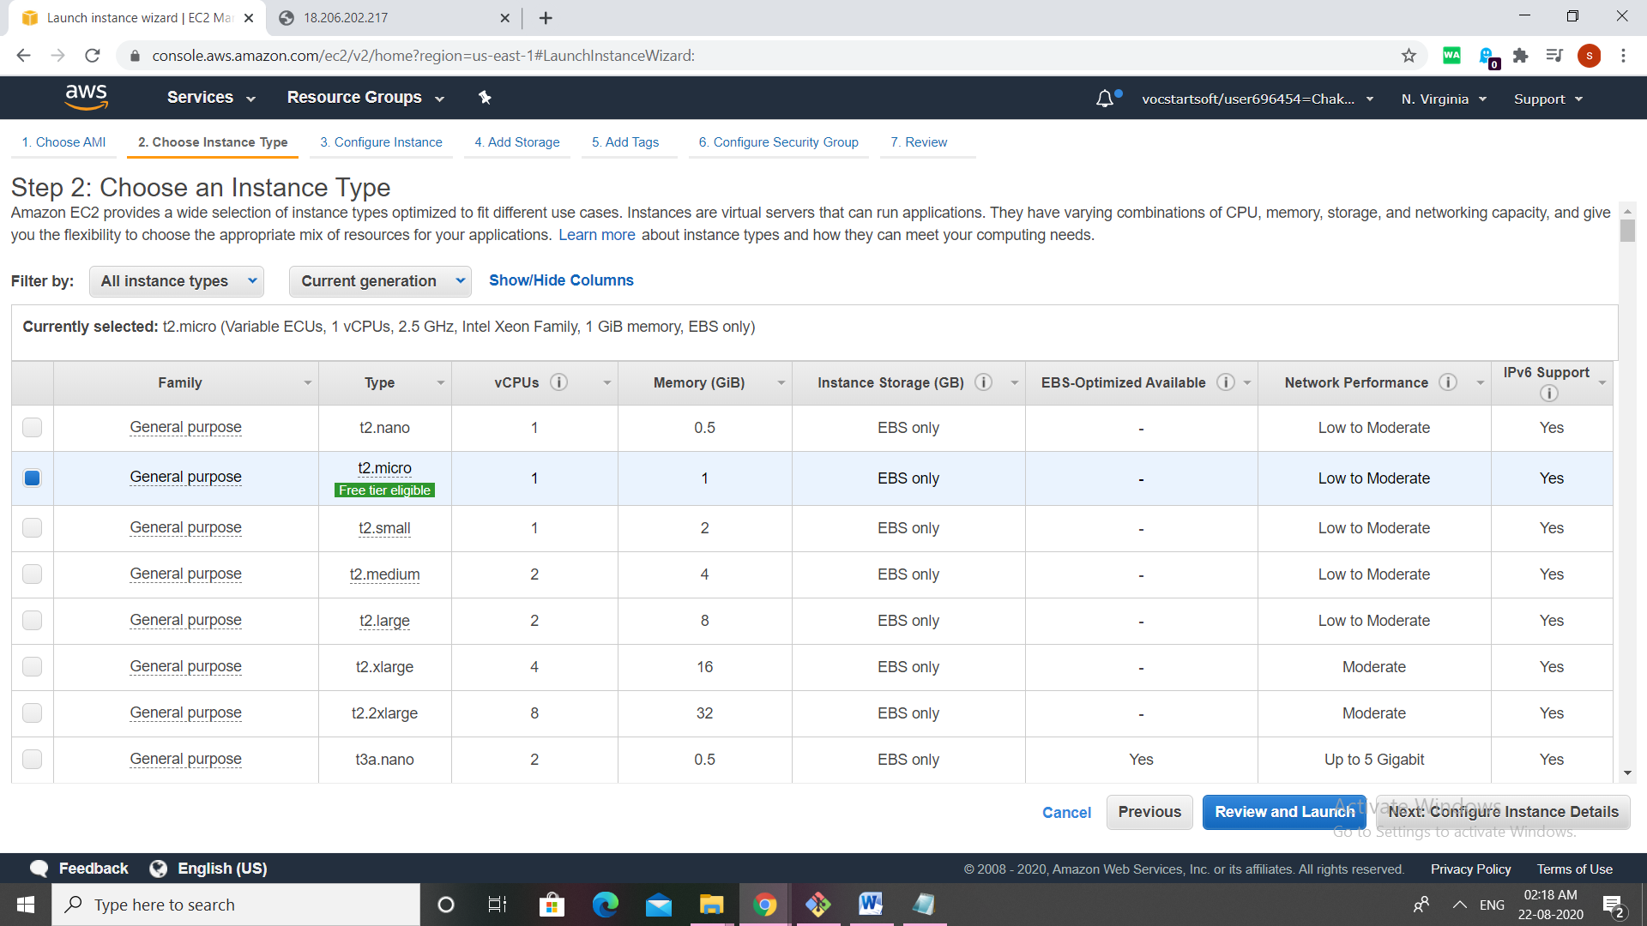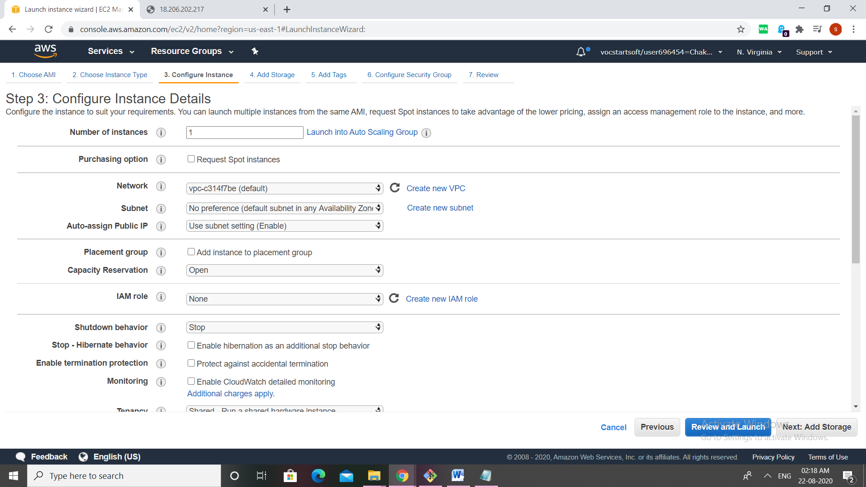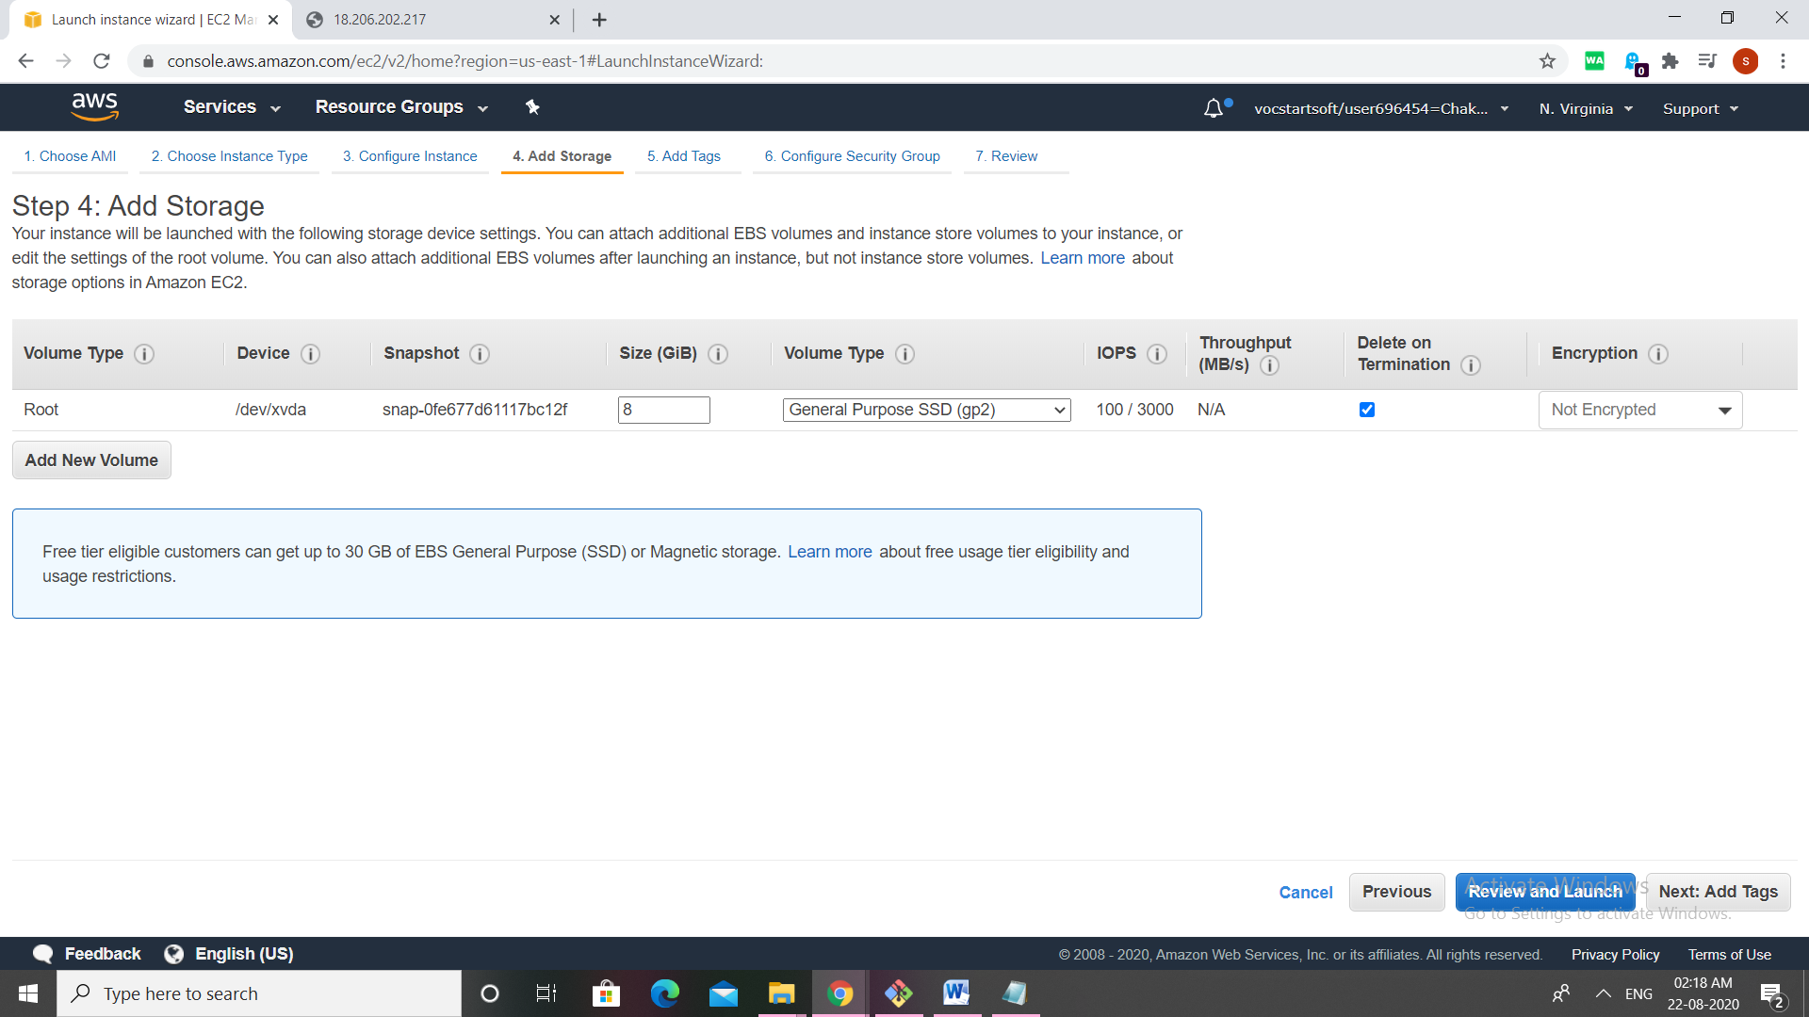 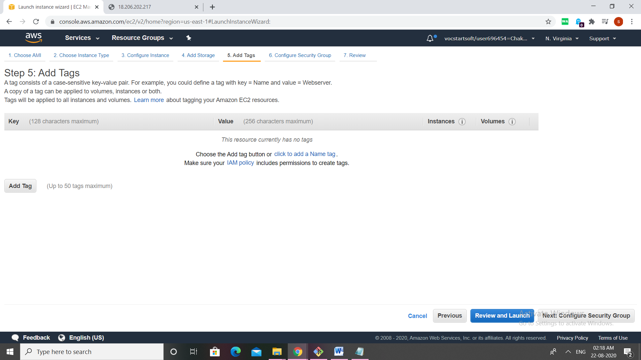 commands:

## 1)ssh -i ~/downloads/first-instance.pem [ec2-user@ec2-18-206-202-217.compute-1.amazonaws.com](mailto:ec2-user@ec2-18-206-202-217.compute-1.amazonaws.com)

## sudo yum -y install httpd

## sudo service httpd start

## sudo service httpd status

## sudo chkconfig httpd on

## sudo su

## echo "Hello. This page is hosted on my AWS EC2 Linux Instance.">/var/www/html/index.html

commands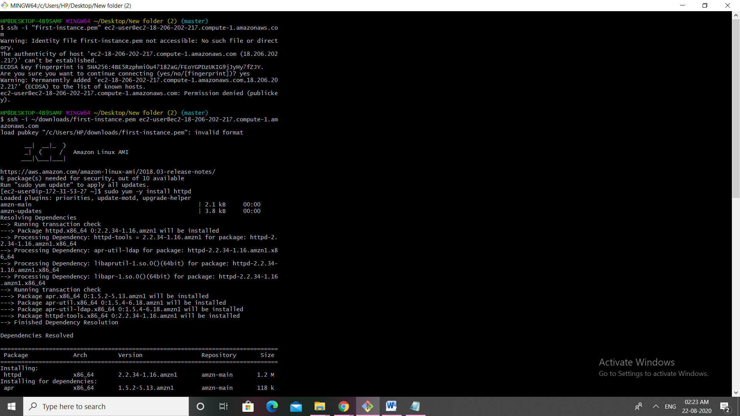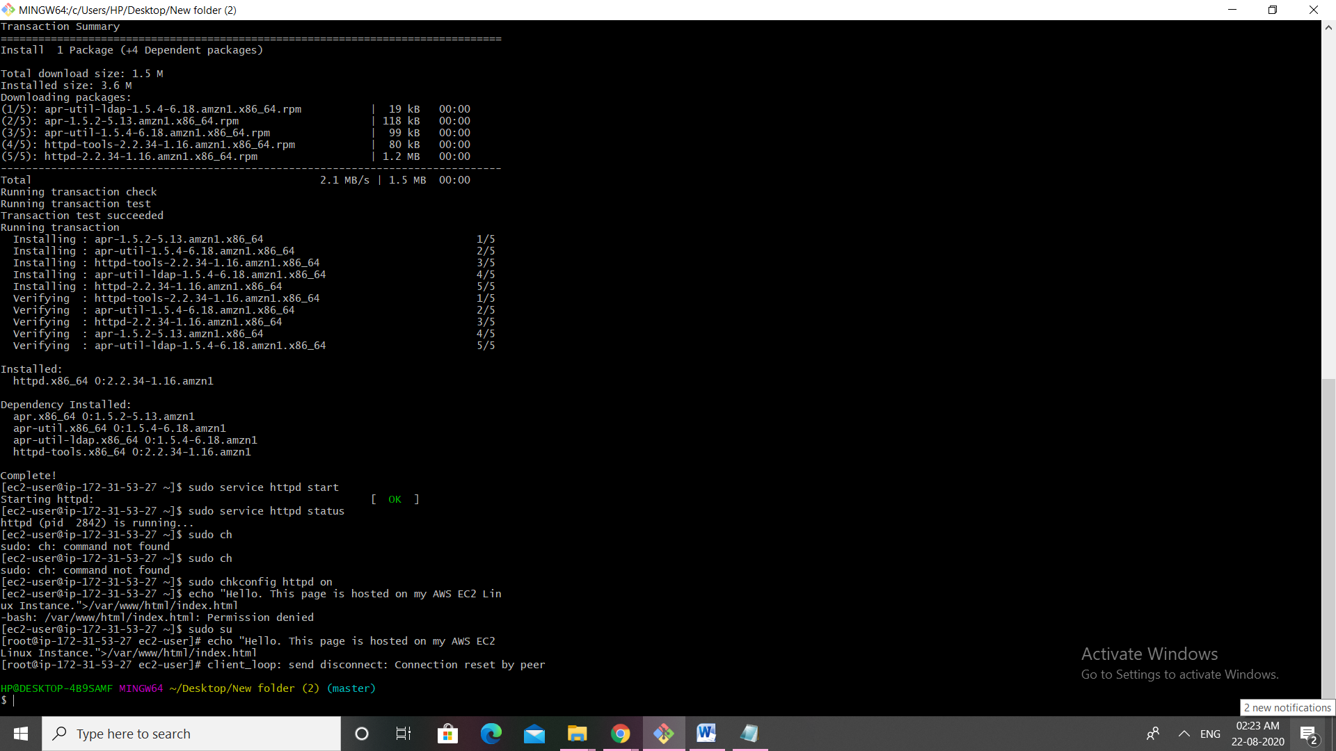

final out put: